**泰森食品有限公司**

**Tyson Foods Inc.**



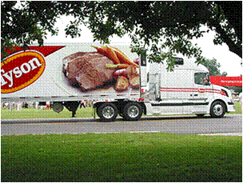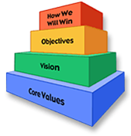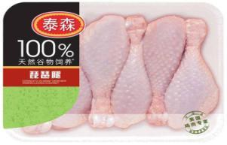

***Tyson–Your Career, Your Family***

* 泰森食品公司成立于1935年，总部在阿肯色州。公司是世界上最大的鸡肉、牛肉和猪肉加工商。

Tyson Foods, Inc. [NYSE: TSN], founded in 1935 with headquarters in Springdale, Arkansas, is one of the world’s largest processors and marketers of chicken, beef and pork

* 公司在美国和世界各地拥有400多个办公地点，雇佣大约115,000名员工。

We have approximately 115,000 team members employed at more than 400 facilities and offices in the United States and around the world.

* 泰森是财富500强的第2大食品公司，也是标准普尔的一员。

Tyson is the second-largest food production company in the Fortune 500 and a member of the S&P 500

* 根据福布斯杂志，泰森是美国最大的100家公司之一。泰森是纽约证交所的上市公司，2010年的营业额为30亿美元。

According to Forbes magazine, Tyson is one of the largest companies in American as well as the listed company in New York Stock Exchange. It has a turnover of $ 3 billion in 2010.

**Tyson History**

**泰森的历史**

**20世纪40年代**

**Tyson Core Value**

**泰森的核心价值观**

**Core Value**

***我们是一家食品生产企业，拥有恪尽职守的员工；我们信奉真理至上、诚信至上；我们在生产中勇于开拓，为我们的股东、客户和员工创造丰厚的价值。***

* 我们来自全球各地，为着一个目标—生产食品而一起努力。
* 我们力求做个诚实正直的人。
* 我们力求成为一家具有坚定信念的公司。

我们的处世原则……

**Who we are**



* 我们提供可信赖的食品给我们的家人、我们的国家及我们的世界。
* 我们精心呵护托付给我们的动物、土地和环境。
* 我们努力为我们的团队成员提供安全的工作场所。

我们的敬业之道……

**What we do**

* 我们努力为我们的股东创造持续、可观的利润，并致力于对员工、产品和生产技术的投资。
* 我们努力诚信经营，并对自己所做的事业坚信不疑。
* 我们努力遵从上帝的旨意，相互尊重，同时尊重我们的客户和其他股东。

我们的制胜举措……

**How we do**



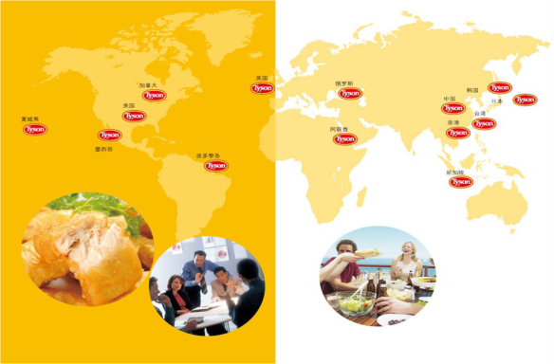

***Tyson in China***

**截至2011年底，美国泰森国际控股有限公司在华总投资将超过4.5亿美金，员工总数亦将达到11000人**

**Tyson-controlled joint ventures will have invested 450 million dollars in China and employed more than 11,000 Team Members by the end of 2011**

**1. 泰森大龙**

**2001年5月成立，位于山东省诸城市**

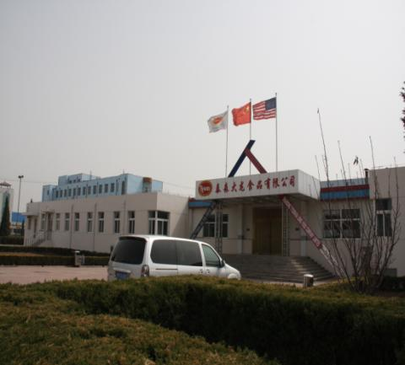Established in May 2001 , located at Shandong Zhucheng

**专注于为快餐和零售熟食店提供优质的半炸鸡肉产品，拥有两家半熟食品加工厂**

Two half-cooked food processing plants for fast food restaurant and cooked-food shops

**月产能1200-1300吨**

1200-1300 tons monthly production capacity

**泰森拥有65%的股份**

65% ownership since 2001

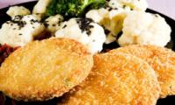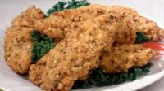

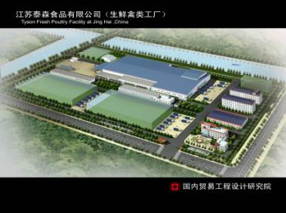

**2. 江苏泰森**

**江苏泰森食品有限公司成立于2008年，位于江苏省海门市。**

Jiangsu Tyson Foods Co., Ltd was founded in 2008 in Haimen, Jiangsu

**专注于为上海和华东地区的快餐和零售业提供生鲜及速冻产品**。

Focused on providing fresh and frozen products for Shanghai and East China fast food and retail industry.

**江苏泰森作为全新的整合型肉鸡生产基地,屠宰量将达到每周一百万只，公司附属的海门泰森禽业发展有限公司，江苏泰森提供安全优质的肉鸡来源，拥有自有饲料厂**

Jiangsu Tyson as a new integrated production base, slaughter nearly one million chickens per week. It is a subsidiary of Tyson Poultry Industry Development Co., Ltd. Haimen, and provides safe source of high-quality chicken with its own feed stuff factory

**公司总投资将达到9000万美元。产品将主要通过零售渠道面对上海，江苏和浙江一亿三千九百万消费者。**

The total investment will reach $ 90 million. Products primarily will be sold to one hundred thirty-nine million consumers in Shanghai, Jiangsu and Zhejiang through retail channels

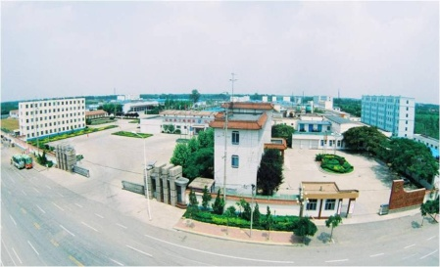

**3.泰森新昌**

**拥有4座家禽屠宰 工厂**

Four poultry slaughter facilities

**日照分公司于2008年8月正式落成**

Rizhao Branch was officially established in August 2008

**两座拥有出口日韩欧美资质的家禽处理加工厂，拥有每周300万只鸡的最大产能**

With 3 million chickens per week maximum capacity, 2 poultry processing plants which are qualified to

export to Japan, South Korea, Europe and America

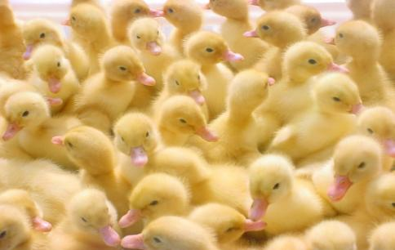 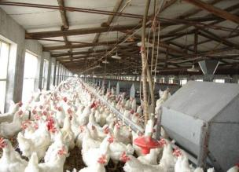

**工作在泰森**

**Work in Tyson**

**为何选择泰森?**

Why to choose Tyson?

加入泰森这个大家庭不仅意味着你获得了一份在500强的体面工作,更意味着你进入了一个职业发展的高阶平台，在这里,我们为每一位员工准备了完整的教育培训计划和职业发展项目 ---- 从初级职位到高级管理岗位一应俱全.我们的核心价值观、国际行为准则和员工权利法案充分体现了泰森对每一位员工的尊重及对我们生活和工作的社区的关怀。

Working for Tyson Foods offers more than a great job. Education training and career development and programs are available from elementary level to senior level, and we actively foster an environment where everyone has access to these opportunities. Our Core Values, Code of Conduct, and Team Member Bill of Rights express Tyson Foods’ commitment to its Team Members and the communities in which we live and work.

**个人发展和职业发展的良机**

**Personal Development and Career Development Opportunities**

泰森设有专业的培训机构，为员工提供持续培训的机会， 帮助员工提高业务水平和自身能力。泰森通过每年的绩效考评流程（IDP），对每位员工的工作成绩进行测评，同时经理跟员工也会坐在 一起沟通，根据员工的个人能力，发展愿望设定其下一步职业发展的目标，并确立具体的发展/培训计划和发展措施。

Tyson has a professional training organization and provides staff with many training opportunities to help them to improve their business standards and capabilities. Tyson assesses every employee’s work through the annual performance appraisal process (IDP), and the managers will communicate with you about your personal ability, career development, and goal setting. They also will help you to establish specific development / training programs and development initiatives

**工作和生活的平衡**

**Work–Life Balance**

我们希望自己的员工干劲十足、事业有成。为此，我们将帮助你在工作和生活之间取得最佳平衡。我们为员工提供灵活工作安排选择，具体取决于当地情况和法律要求，其中包括弹性工时，远程办公和休年假等。

We expect our employees to be motivated, successful. For this reason, we will help you achieve the best work-life balance. We will also offer flexible work arrangements for employees , depending on local circumstances and legal requirements, including flexible working hours, telecommuting and annual leave and so on.

**企业文化和价值观**

**Culture and values**

我们认为，一家国际化企业的成功，并不仅仅意味着经济上的成功，它还必须履行社会责任和注重环保。我们以自己的行动诠释我们的价值观。这些价值观是我们赖以生存和发展的基础。

We believe that a successful international enterprise not only means economic success, but it also must fulfill their social responsibility and pay attention to the environment protection. We interpret our values​​ through actions as our survival and developing bases.

**人才发展**

** Talent program**

* **在校生(Students)**

你是一个急于开始自己职业生涯的在校学生么？我们能够为你提供体验工作的机会，即使你尚未完成你的学业——通过实习或校企合作项目。只要你具有开放性的思维、积极进取和较强的学习能力，泰森都是你理想的选择。

If you are rush to start your career, we can provide you the opportunity. If you have not yet completed your studies, you can also join our internships or school-enterprise cooperation projects. As long as you are an open-minded, positive and quick learner, Tyson is your ideal choice.

* **应届毕业生(Gradutes)**

如果你已经毕业或即将毕业，并以优异的成绩通过了毕业考试，并仍具有开放性思维，你一定会觉得泰森是你开始职业生涯的理想场所.

If you have graduated or will graduate and still have creative minds, you are certain to think Tyson would be your ideal place to begin a career

* **泰森管理培训生项目(Management Trainee Program)**

泰森管理培训生项目（Tyson MT）是一项专为高素质人才设立的在职管理培训项目，该项目为期2-3年，其突出特点在于广泛的培训与发展活动，通过轮岗，一对一辅导，导师计划等多样的学习与培训，提升培训生的专业技能与领导力。项目进程的决定因素包括培训生的个人兴趣，工作能力以及公司的业务需求。

Tyson Management Trainee Program (Tyson MT) is set up for people with high capability and lasts nearly 2-3 years. Its outstanding feature lies in its extensive training and development activities, through working shift, one-to-one consulting, and teaching program or other diversified learning and training activities to enhance the participants’ professional skills and leadership. The determined factors of the project process include the participants’ interests, working ability and the company's business needs.

项目介绍Program Introduction：

项目目的：挑选高素质的应届毕业生，使他们发展成为泰森中国未来的领导力量

Program Purpose：Select high-quality graduates to develop them into future leaders of Tyson China

项目为期时间：2 -3年

管理培训生项目

Management Trainee Program

Management Trainee Program

招募农业大学中具备较大潜力以及高文化素质的应届毕业生

Recruit high potential graduates with good cultural cultivation from agriculture universities

绩效管理系统（绩效评估）

Performance Management System (Performance Evaluation)

培训和发展计划

Training and Development Programs

是为将来活禽生产和加工部门输送

中高级人才的重要来源之一

One of the key sources for future middle to senior level management pool for Live Production and Processing

Program Duration：2- 3 years

**有经验人士(Experienced Talents)**

如果你已经有三年以上的专业技术工作经验，希望迎接新的挑战，或者在现有的职业发展道路再进一步。泰森能够提供众多机会，帮助你实现自己的事业目标。

If you have more than three years of professional working experience and expect to meet new challenges, or go further on your previous work, Tyson provides many opportunities to help you achieve your career goals.

**Address: Room 501. Building One No. 388 Tian Lin Road Shanghai, China**

地址：上海市田林路388号1号楼501室

**Post code:200233**

邮编：200233

**Telephone: 021-24117600**

电话：**021-24117600**

**Fax: 021-54902002/021-54902008**

传真：**021-54902002/021-54902008**

**Website: www.tyson.com.cn**