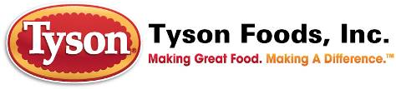

TYSON Cross Training Program
泰森TCT海外学习项目

2012-5


内容目录Contents

关于泰森About Tyson 3
今天的泰森 Tyson Today 4
我们的核心价值观 Tyson Core Values 5
我们的处世原则 Who we are 5
我们的敬业之道 What we do 5
我们的制胜举措 How we do it 5
产品安全Products Safety 6
泰森的可持续发展宣言Sustainability at Tyson 7
环境、健康和安全政策EHS Policy 7
人才发展People Development 8
我们的产品Tyson products 9
国际分支机构 International 10
泰森鸡肉产业链 The Tyson production chain 11
泰森在中国 Tyson in China 12
泰森大龙Tyson DL 12
泰森江苏 Tyson JS 13
泰森山东 Tyson SD 13
为何选择在泰森工作Why work at Tyson 14
TCT项目介绍TCT Program introduction 15
学习科目Curriculum for TCT 16
如何申请 How to apply 16
申请标准Application Criteria 16
申请方式Application Channel 17
常见问题回答 FAQ 17
联系我们Contact us 18

关于泰森About Tyson
- 创始于1935年，总公司位于美国阿肯色州，是目前全球最大的鸡肉、牛肉、猪肉供应商及生产商
- Tyson Foods, Inc. [NYSE: TSN], founded in 1935 with headquarters in Springdale, Arkansas, is one of the world’s largest processors and marketers of chicken, beef and pork
- 在全球范围内拥有400多家工厂及办事处和115,000余名员工
We have approximately 115,000 team members employed at more than 400 facilities and offices in the United States and around the world.
- 泰森是财富500强的第2大食品公司，也是标准普尔的一员。
Tyson is the second-largest food production company in the Fortune 500 and a member of the S&P 500
- 根据福布斯的排名,是全美最大的100家企业之一
According to Forbes magazine, Tyson is one of the largest companies in American
- 作为纽约证券交易所的上市公司,2011财年泰森的总产值达到323亿美元
As the listed company in New York Stock Exchange，its gross product is about 32.3 billion.
- 产品遍销全球80多个国家和地区
Products are sold in more than 80 countries and regions.

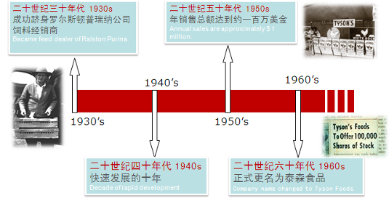
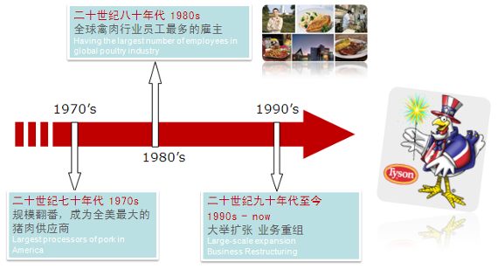

今天的泰森 Tyson Today
- 连续七年登上全球最佳创新食品企业的宝座 Awarded the world's best innovative food companies through 7 years
- 为我们的家人、国家及世界提供值得信赖的食品 Feed our families, the nation, and the world with trusted food products.
- 精心呵护那些托付给我们的动物、土地和环境 Serve as stewards of the animals, land, and environment entrusted to us.
- 努力为股东创造持续、可观的利润，并致力于对员工、产品和生产技术的投资 Strive to earn consistent and satisfactory profits for our shareholders and to invest in our people, products, and processes.
- 诚信经营、并对自己所做的事业坚信不疑 Strive to operate with integrity and trust in all we do.
- 始终关注企业和员工的可持续发展 Always concern about the sustainable development of enterprises and employees

我们的核心价值观 Tyson Core Values
我们是一家食品生产企业，拥有恪尽职守的员工；我们信奉真理至上、诚信至上；我们在生产中勇于开拓，为我们的股东、客户和员工创造丰厚的价值。
We are a company of people engaged in the production of food, seeking to pursue truth and integrity, and committed to creating value for our shareholders, our customers, and our people in the process.

我们的处世原则 Who we are
- 我们来自全球各地，为着一个目标—生产食品而一起努力。
We strive to be a company of diverse people, working together to produce food.
- 我们力求做个诚实正直的人。
We strive to be honorable people.
- 我们力求成为一家具有坚定信念的公司。
We strive to be a faith-friendly company.

我们的敬业之道 What we do
- 我们提供可信赖的食品给我们的家人、我们的国家及我们的世界。
We feed our families, the nation, and the world with trusted food products.
- 我们精心呵护托付给我们的动物、土地和环境。
We serve as stewards of the animals, land, and environment entrusted to us.
- 我们努力为我们的团队成员提供安全的工作场所。
We strive to provide a safe work environment for our Team Members.

我们的制胜举措 How we do it
- 我们努力为我们的股东创造持续、可观的利润，并致力于对员工、产品和生产技术的投资。
We strive to earn consistent and satisfactory profits for our shareholders and to invest in our people, products, and processes.
- 我们努力诚信经营，并对自己所做的事业坚信不疑。
We strive to operate with integrity and trust in all we do.
- 我们努力遵从上帝的旨意，相互尊重，同时尊重我们的客户和其他股东。
We strive to honor God and be respectful of each other, our customers, and other stakeholders

产品安全Products Safety
- 泰森已通过ISO:9001的认证/ Pass through ISO:9001 verification
- 各工厂有完善的HACCP体系/ Implement the HACCP system in every plant
- 遍布各地区的一级实验室/ Laboratory exist in all the Tyson plant
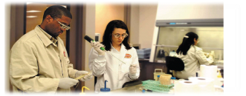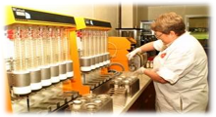

泰森的可持续发展宣言Sustainability at Tyson

“泰森食品公司认识到作为负责任的公司的重要性。我们的核心价值定义了我们是谁，我们做什么和如何做，是我们泰森可持续发展的基石。我们决定将我们公司发展成经济上、环境上和社交上都是可持续发展的公司。我们在这方面的努力会被衡量为我们如何发展和销售我们的产品，我们怎么对待动物、土地和环境，包括我们如何对待人员，包括员工、消费者、供应商和我们所在的社区。”
Tyson Foods, Inc., recognizes the importance of being a responsible corporate citizen. Our Core Values – which define who we are, what we do, and how we do it – are the foundation of corporate sustainability at Tyson. We are committed to making our company sustainable – economically, environmentally, and socially. Our progress in this endeavor will be measured by how we develop and market our products, how we care for the animals, land, and environment entrusted to us, and how we treat people, including our Team Members, consumers, suppliers, and the communities in which we live and operate.
泰森食品公司主席 约翰泰森John Tyson

环境、健康和安全政策EHS Policy
- 我们的核心价值作为我们的基础，泰森公司的政策是在对环境和员工和邻近社区负责任的方式开展业务。我们相信保护和保持自然环境对我们公司的可持续发展和世界的将来都非常重要。我们相信我们的员工、合同商和参观者有权利在安全的环境中工作。
- With our Core Values as our foundation, it is Tyson Foods’ policy to conduct business in a safe, responsible manner with respect for the environment and for the well-being of our Team Members, customers, and neighboring communities. We believe that conserving and protecting natural resources is essential to our company’s sustainability as well as the future of the world.


人才发展People Development
- 泰森公司的雇员，我们称为员工，是我们最重要的资产。我们的持续成功建立在他们的知识、技能和才能之上。我们承诺吸引、发展和保留员工，并提供一个允许彼此为公司成功出力的工作环境。
The employee of Tyson, we called staff, is our most valuable assets. We success continuously based on the Knowledge, Skills and competencies of our staff. We commit to attract, develop and retain the staff, and provide a work environment allowing them to work to help Tyson success.
- 泰森多次被评选为美国最佳雇主，排名靠前
Tyson has been awarded “The Best employer “ of United States for many times with top ranking.

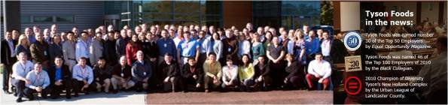

我们的产品Tyson products
为全球80多个国家和地区提供最优质的猪肉、牛肉、鸡肉等肉类产品和服务
We provide the food of Pork, Beef, Chicken with the great quality over 80 countries and areas in the world.
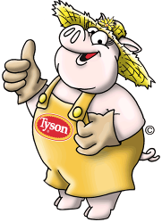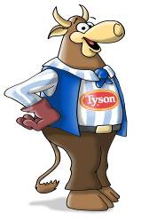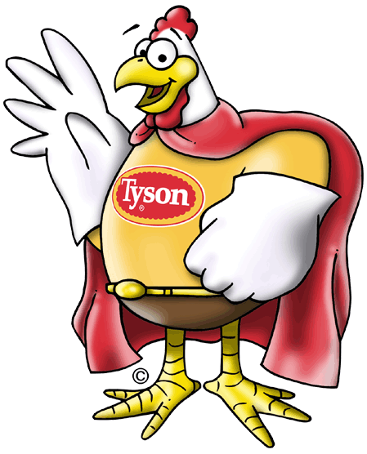

国际分支机构 International
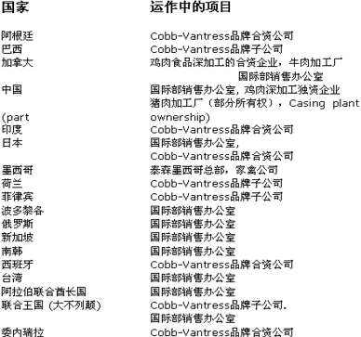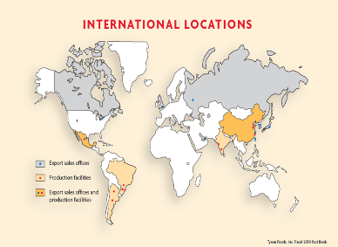

泰森鸡肉产业链 The Tyson production chain
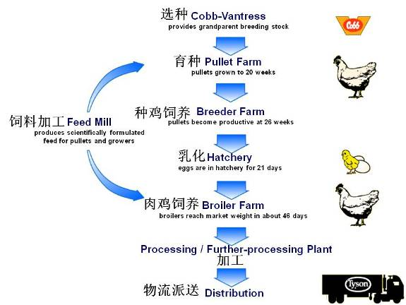

泰森在中国 Tyson in China
- 截至2011年底，美国泰森国际控股有限公司在华总投资将超过4.5亿美金，员工总数亦将达到11,000人。 Tyson-controlled joint ventures total 450 million dollars in investments and will employ more than 11,000 Team Members by the end of 2011.
- 三种业务模式打造多样化产品平台:
Diversity products platform comes from three Kinds of Business Models:

泰森大龙Tyson DL
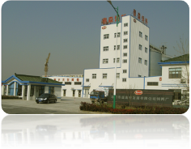
- 成立于2001年，专注于为快餐和零售熟食店提供优质的半炸鸡肉产品，泰森拥有65%的股份 Tyson Dalong - Par-Fry chopped and formed poultry products for QSR and retail Deli – 65% ownership since 2001
- 拥有两家半熟食品加工厂
- 月产能1200-1300吨

泰森江苏 Tyson JS
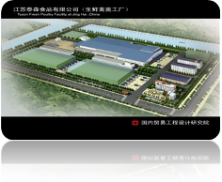
- – 成立于2008年，从养殖到加工到销售的全面整合产业链。专注于为上海和华东地区的快餐和零售业提供生鲜及速冻产品，周产量最大可达1百万只鸡 ，泰森全资子公司Jiangsu Tyson - Raw Fresh - fully integrated chicken, long shelf life, fresh and frozen branded chicken sold to QSR and retail chains for Shanghai and East China region 1M BPW maxim capacity - 100% Tyson ownership since 2008

泰森山东 Tyson SD
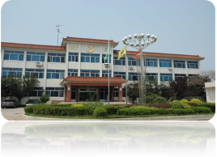
- – 专注于为全国快餐业提供优质的深加工鸡鸭肉即食及速冻产品， 2座拥有出口日韩欧美资质的家禽处理加工厂 -周产量最大可达3百万只鸡，泰森全资子公司 Tyson Xinchang – Fully integrated chicken and duck, cut up and 100% frozen, national distribution, wholesale and QSR – 2 Fully Cooked plants, export certified for Japan, Korea, EU and US - 3M BPW maximum capacity at 2 processing plants – 100% ownership since 2009

为何选择在泰森工作Why work at Tyson
- 世界500强公司的工作机会 Tyson Foods offers a great job opportunities
- 尊重及关怀我们的员工及利益相关者 Respect and commitment to its Team Members and to the communities
  - 核心价值观Our Core Values
  - 国际行为准则Code of Conduct,
  - 员工权利法案,Team Member Bill of Rights
- 完整的教育培训计划和职业发展规划 Education and career opportunities are available
  - 初级职位entry level positions
  - 高级管理岗位 senior management
- 泰森领导力学院 Tyson leadership college
  - 拥有多项提高员工和组织工作效率的培训项目A number of training programs to improve staff and organizational efficiency.
  - 每月在公司总部开展丰富多彩的培训活动以帮助员工更好地发展自我 Offer a variety of professional training courses to improve your quality.
  - 除此之外，导师计划和网络教学也是职业发展培训的重要组织形式 In addition, classroom teachings, mentoring and online teaching are the important ways to career development training.

TCT项目介绍TCT Program introduction
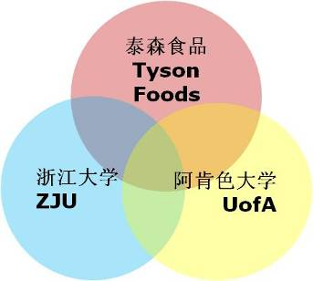

- 泰森、浙大及阿肯色州大学联合培养活禽专家
- Tyson, ZJU and UofA work together to develop poultry expert
- 选择合格的一年级研究生，从2012年8月开始送至阿肯色大学学习及在泰森美国Springdale实习一年 (其中9个月在阿肯色大学，3个月在泰森美国实习)
- Select and send the qualified junior postgraduates to attend UofA as full-time students and intern at Tyson Springdale for a year from Aug. 2012 (9months at UofA, 3 months at Tyson Springdale)
- 泰森全额资助该项目
- Tyson fully funding this program
- 在活禽科学导师指下，学习西方活禽科技
- Learn western poultry science and technology with poultry science faculty
- 学习泰森活禽流程、企业文化及领导力发展
- Learn about Tyson poultry process, cultural tenants, and leadership and development
- 整合海外学习和就业，需要承诺在泰森服务5年（加入TCT就意味着世界500强企业就业机会）
- Integrate overseas training and career with 5-year commitment working at Tyson

学习科目Curriculum for TCT
2012年秋学期Fall 2012
- Poultry production: meat活禽生产：肉鸡
- Avian diseases 禽类疾病学
- Avian genetics 禽类遗传学
- Egg and Meat Technology 鸡蛋与鸡肉科技
- Seminar 研讨会
2013年春学期Spring 2013
- Poultry production: breeders活禽生产：种鸡
- Avian anatomy 禽类解剖学
- Poultry nutrition 禽类营养学
- Seminar 研讨会
- Special problem: “Specialization area”
- 专题问题研究：专门领域研究
2013年夏学期Summer 2013
- Internship: “Tyson Foods Springdale”
- 在泰森Springdale公司实习

如何申请 How to apply

申请标准Application Criteria
- 符合泰森企业文化和价值观 Fit with Tyson Culture and Values
- 愿与泰森中国一起发展（需服务泰森5年）Will grow with Tyson China together (with 5 years working commitment)
- 在校一年级研究生 Grade one post graduates
- 专业要求： Requirement of major
  - 动物遗传育种与繁殖、动物营养与饲料科学、预防兽医学、基础兽医学、临床兽医学、养殖、兽医硕士
- 英语水平：能满足美国大学的学习要求（有GRE/GMAT/Tofel等优先）
English level: Can meet the requirement of studying in US
- 通过泰森测评中心测试 Pass Tyson assessment
- 无任何不良纪录 No violation recordings

申请方式Application Channel
- 通过邮件进行申请，将您的申请发送至以下邮件 Please email your application to：
Recruitment_China@tyson.com
- 请在邮件标题中注明“TCT-姓名-专业”
Please specify the email subject as “ TCT-your name-your major”

常见问题回答 FAQ
- 这个项目哪些人可以申请？ Who can apply TCT?
  - 在校一年级研究生。 The postgraduates in junior grade.
  - 致力于活禽科学。 People who will dedicate himself to poultry science.
- 这个项目有专业要求吗？ What major is required?
  - 动物科学研究领域相关专业，包括动物遗传育种与繁殖、动物营养与饲料科学、预防兽医学、基础兽医学、临床兽医学、养殖、兽医硕士等
- 这个项目有人数限制吗？Is there limitation of number of people?
  - 没有，我们会选择符合要求的人员参加。No. We will select the qualified people to attend this program.
- 申请者需要提供什么材料？ What materials need be provided when applying?
  - 填写申请表 application form
  - 学校出具的学习成绩证明 study score sheet provide by university
  - 英语水平证明 English level certificate
  - 护照，等 passport，etc.
- 什么时候知道申请结果？ When we can know the result?
  - 5月底前 by end of May.
- 我没有护照可以申请吗？ Can I apply if I have no passport?
  - 可以。在提出申请后，你应该尽快办理护照。 Yes. You should apply a passport when you apply for TCT.
- 我没有GMAT, GRE, TOFEL等成绩可以申请吗？ Can I apply if I have no certificate of GMAT, GRE, TOFEL ?
  - 可以。如果有这些成绩会更容易申请成功。如果你没有这些成绩，泰森会安排英语水平测试。 Yes. It is easier for you to apply for TCT. If you have no these certificate, Tyson will arrange English level test for you.
- 参加这个项目是否就意味着加入了泰森公司？ Does it mean the people who join TCT will join Tyson?
  - 是的。所有加入这个项目的人需要承诺服务泰森5年，毕业后必须到泰森中国公司工作。 Yes. The people who join TCT with 5 years commitment to work for Tyson China after graduation.
- 在美学习一年期间可以回中国吗？ Can I come back during this year?
  - 在没有特殊情况下，原则上，中途是不回中国的。 Generally speaking, no.
- 整个学习期间申请人需要支付哪些费用？ What expense need be covered by applicant?
  - 申请者几乎不用出任何费用，泰森会提供学习期间住宿、正常餐费、学费、来回中国与美国的机票、护照及签证费用等。 The applicant don’t need pay any expense for TCT program, Tyson will cover all expenses related to TCT program.

联系我们Contact us
联系电话：021-2411 7517 或 2411 7518
电子邮件：Recruitment_China@tyson.com
公司网站：www.tyson.com

