Treating injured raptors - repair, rehabilitate and release

The seminar will cover the veterinary care needed to treat injured raptors (hawks, owls and eagles), and will also include a discussion about how the natural history of these birds must be considered when making decisions on releasing them to the wild.

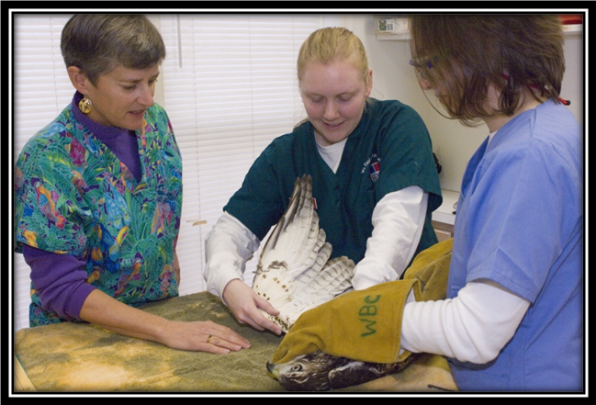

Dr. Degernes and veterinary students examining a hawk

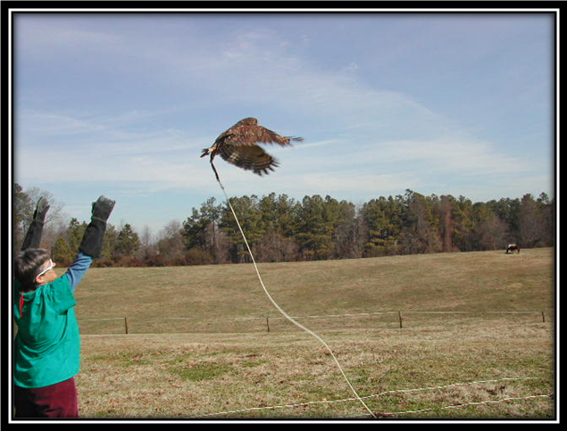

Dr. Degernes test-flying an owl prior to release.

Dr. Laurie Degernes is an avian veterinarian and an expert in treating and rehabilitating injured raptors for release to the wild. She is an associate professor at North Carolina State University in Raleigh, North Carolina, United States.

**2012-5-10 9：00---11：00 E524**